Mathias König von Paumbshausen, Stempelschneider
(Stempelschneider = Coin die maker)
Information collected and translated by
R.E. Butler, October 2012

Introduction
This document was prepared as part of a genealogy study for the König von Paumbshausen family. It includes all the references to Mathias König from the book, “Die Münzstätte Hall in Tirol 1477 - 1665”. It also includes all the references to his son Maximilian, and to Wolfgang Eggl, who was probably Mathias’ father in law.

Sources of Information
An overview of the “History of Austrian Money” has been provided by the Austrian National Bank at: http://www.oenb.at/en/ueber_die_oenb/geldmuseum/oesterr_geldgeschichte/history_of_austrian_money.jsp
Much more detail about the mint at Hall near Innsbruck is given in the book:
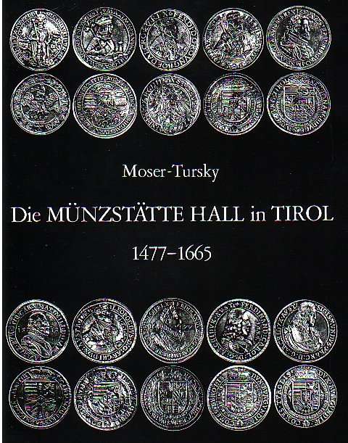

This book was published in Innsbruck in 1977 by Dr. Rudolf Erhard, Rum. It is listed in the catalogue of the American Numismatic Society at: http://donum.numismatics.org/cgi-bin/koha/opac-detail.pl?biblionumber=31434&shelfbrowse_itemnumber=9183
It can be purchased through several on-line vendors. There is also a companion book which covers the years 1665 -1809.
The book seems to be primarily a numismatic history and catalogue of coins produced at Hall, but it also includes enough history about the rulers of Austria, to put the coin history in perspective. It includes a list of all the mint masters, ( Münzmeister), and all the coin die makers (Stempelschneider) who created the individual coins.

It is 372 pages long and includes hundreds of references to old documents. It would seem to be a very reliable source of information.

Information Extracted from “Die Münzstätte Hall in Tirol 1477 - 1665”
Selected sections of the book were scanned and processed by an OCR program at http://www.free-ocr.com/ to produce plain text in the German language. References have not been included. It was then translated to English with the help of Google Translate, and quite a bit of interpretation by the author. The German language text is an accurate copy of the book, but the translation has to be considered as approximate. Although the translation is not perfect, it does show the nature and extent of Mathias König’s work. His work was of high quality and was evidently appreciated by royalty.
The author would be very pleased to receive any comments which would improve the translation. Please email comments to: rebutler@storm.ca
The extracted text in German is in the file:
“Mathias König Stempelschneider - Deutsch.doc“

The translated text in English is in this file:
“Mathias König Stempelschneider - English.doc”

Extracted Text Translated to English.
References to Matthias and Maximilian König on pages 262 - 354
Page 262
At the beginning of 1626, there were new circumstances at the Hall mint. In March 1626, Matthias König, later the Hall Eisenschneider, had to cut a new seal for Archduke Leopold V, which would correspond to the new political, (including ecclesiastical) situation.

Pages 273 - 274
Claudia von Medici as Guardian and Regent
1632 — 1646

On 13 September 1632 Archduke Leopold V died in Schwaz after a violent fever, which he contracted in a hunt in Achentale. In his will, he had named his wife, Archduchess Claudia de Medici and the Emperor (Ferdinand II until 1637, then Ferdinand III.) as guardians for his eldest son, Ferdinand Karl (born in 1628) Since the emperor at that time was busy with the political events in the midst of the Thirty Years War he could hardly manage to be the guardian. Claudia de Medici had to steer her four year old son, the only heir, through adolescence.

Her first action in relation to coinage was the provision that all coin denominations continue to show the image of her late husband Archduke Leopold V and, where the date was used, it should be 1632 A government seal was needed, so Matthias König immediately cut a seal for her, and the second guardian, Emperor Ferdinand II.

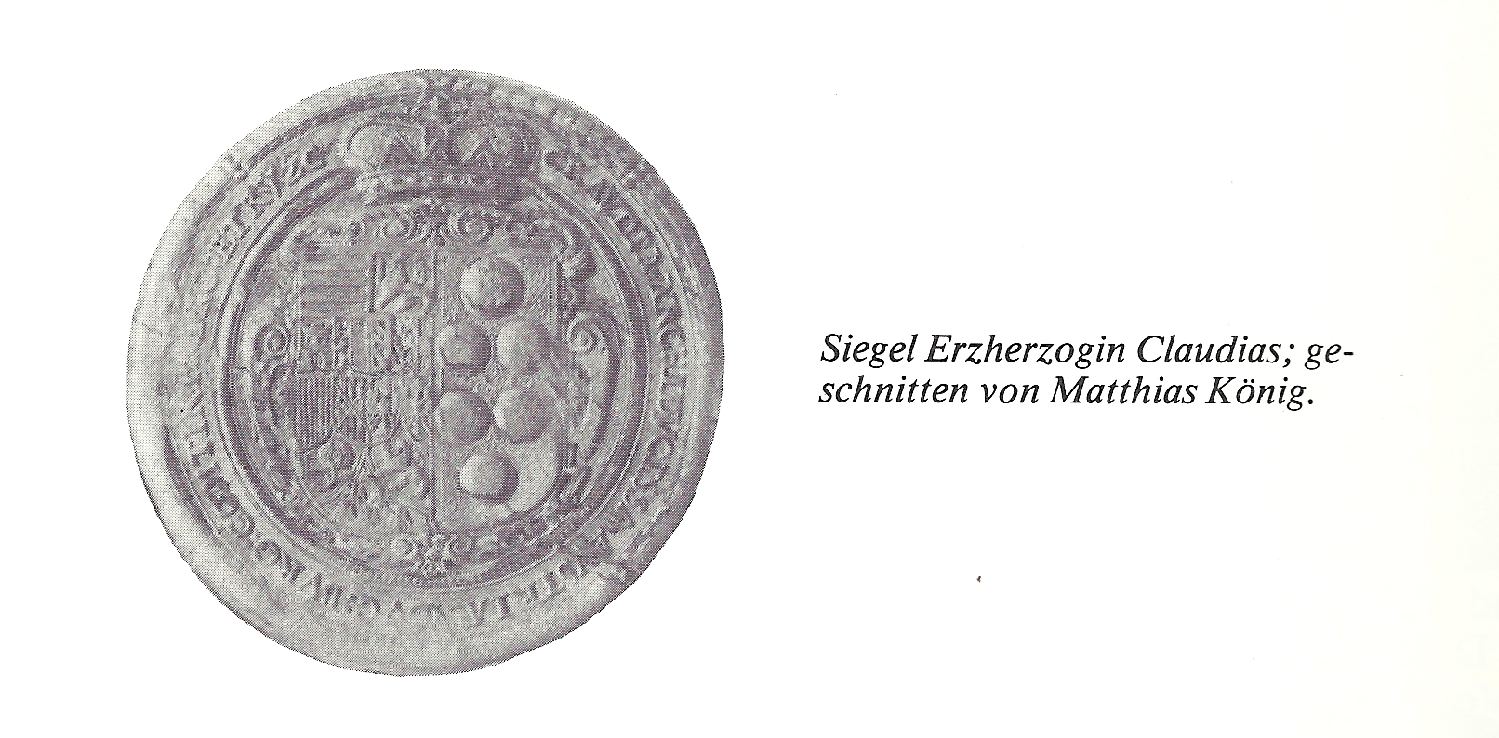 '

Matthias König, who had cut the seal of Archduke Leopold V several years before was able to show his artistic talent. He had previously tried in 1630 to be the engraver in Hall, and up to 1633 was working alongside Christof Amende as second engraver. He was not hired permanently, but was paid separately for each of his works which were extensive. He received 80 fl for all Taler rolls delivered by him in 1633. König was recognized for his work, and soon the Innsbruck authorities thought of terminating Christof Amendes. But Archduchess Claudia decided that Amende remain temporarily in his office and König should be provided with another office Soon, however, there were difficulties between Amende and König. The former eventually resigned from his office in 1635 and was compensated with an annual pension of 100 fl. Amende retired to Innsbruck, where he died in 1643 or 1644 As appears from various clues, his work for the Hall mint in his final years was mainly to cut embossing rollers for Threes and Tens while the Taler rollers were supplied almost exclusively by Matthias König As mentioned above, the coins still had the image of Archduke Leopold V. With few exceptions, all posthumous Taler rolls marked with the year 1632 were delivered by Matthias König.

Matthias König was born in Olmütz and came to Innsbruck in 1620, where he settled for the time being as the coat of arms and seal cutter. In 1632 he was appointed as successor to Melchior Patz as engraver for the archbishop of Salzburg, at least until 1654, and possibly longer.

Page 277
The rollers for Tens were engraved by Christof Amende up to 1635. Those of 1636 and 1637 by Matthias König (all dated with year 1632)

Page 278
In order to distinguish these 7 lots of 3 Taler coins, it was decided to represent the eleven year old Ferdinand Karl on the front. The Hall mint would therefore be one of the few who put the portrait of a child on one of their coins. The design of the reverse side was not changed for the time being and shows the three Leopold coats of arms. There were 687,949 pieces of these 3 Taler coins minted. However, despite the change of ruler portrait on these coins to make sure they were not confused with the old coins, Matthias König was instructed to design a new reverse and fix the year on the front on either side of the portrait. Matthias King delivered two drafts of a new reverse side, and the second, which shows the Tyrolean eagle and the Austrian shield was used. The design of the reverse is reminiscent of the Tyrolean Tipper coins.
[Translators note: front & back = obverse & reverse = heads & tails]

Page 281
It is also possible that this was the work of Matthias König. The city view in the background could possibly be Hall, which could relate to the monogram. Interpretation of these letters with certainty is not currently possible.

Page 283
Ferdinand Karl 1646 — 1662

Ferdinand Karl, firstborn son and thus legitimate heir of Archduke Leopold V was of legal age in 1646 and able to take over the reins of government himself. On 9 April 1646 the hereditary homage was hosted by Innsbruck. In the same year the 18 year old prince married Anna, daughter of the Grand Duke Cosmo II of Tuscany who was his elder by 10 years. The Archduke Ferdinand Karl showed a special interest in the Hall mint by visiting it after the wedding ceremony. That the young archduke did this first and foremost was documented throughout the world by beautiful commemorative coins, and demonstrated the wealth of his country and the development of Tyrol coinage under his government.

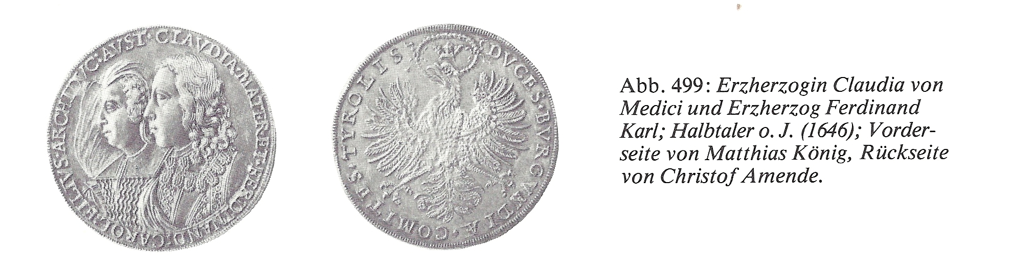

Archduke Ferdinand Karl was at first still strongly under the influence of his mother, Archduchess Claudia de Medici. When new coins were made in 1646, the new half Taler coins showed both Archduke Ferdinand Karl and his mother. The reverse side was chosen as the 1635 engraving by Christof Amende The front, which was of high quality had already had been cut by Matthias Koenig in the summer of 1646. In October the first coins were made from this pair. These images were mainly used for five Ducat coins, and it were rarely used for smaller coins.

In October 1646 they proceeded to design double, whole, half and quarter coins with the image of Archduke Ferdinand Karl. Matthias König delivered two versions of each type, which showed the Archduke once with and once without his mother. No doubt under the influence of his mother, Ferdinand Karl made following decision: The double Talers which were rarely made had the image of the Archduke and his mother. For the single Talers, only the portrait of the archduke was used, because he was shown to the best advantage.

Pages 285 – 287
For the double Taler, Matthias König prepared a stamp roller with the Archduke and another without the Archduke. Stylistically, the simple double Taler retained the lion head and shoulder in 1646.
Up to 1646, the simple Taler coins were minted with an image of Archduke Leopold V. Only a small portion of the coins were minted with the image of Archduke Ferdinand Karl. Only recently, research on the coins with Archduke Leopold V and the year 1632 has proven that embossing rolls had four stamps bearing the image of Archduke Leopold V and the year 1632, and the rolls with images of Archduke Ferdinand Karl had the year 1646
In 1647 there was a personnel change in the Hall Mint. Christof Örber, who had been acting as Master of the Mint since 1613, died in the spring of the 1647. His successor was Martin Hofer. He died suddenly in 1659, so that the Pfannhausamtskassier since 1654, Tobias Fenner was made master of the mint.
In 1647 Matthias König brought his son Maximilian back from the office. Maximilian König was concerned with the stamp section of the mint for the next 4 decades. In the first period of his activity, however, he was placed under the supervision of his father, which went so far as to jointly cut embossing rollers.

It is not possible to distinguish the work of the König father and son on images of Archduke Ferdinand Karl on Taler rolls. Certainly the father was the artistic dominant person at first, and the son worked initially mainly on the dies for coinage.
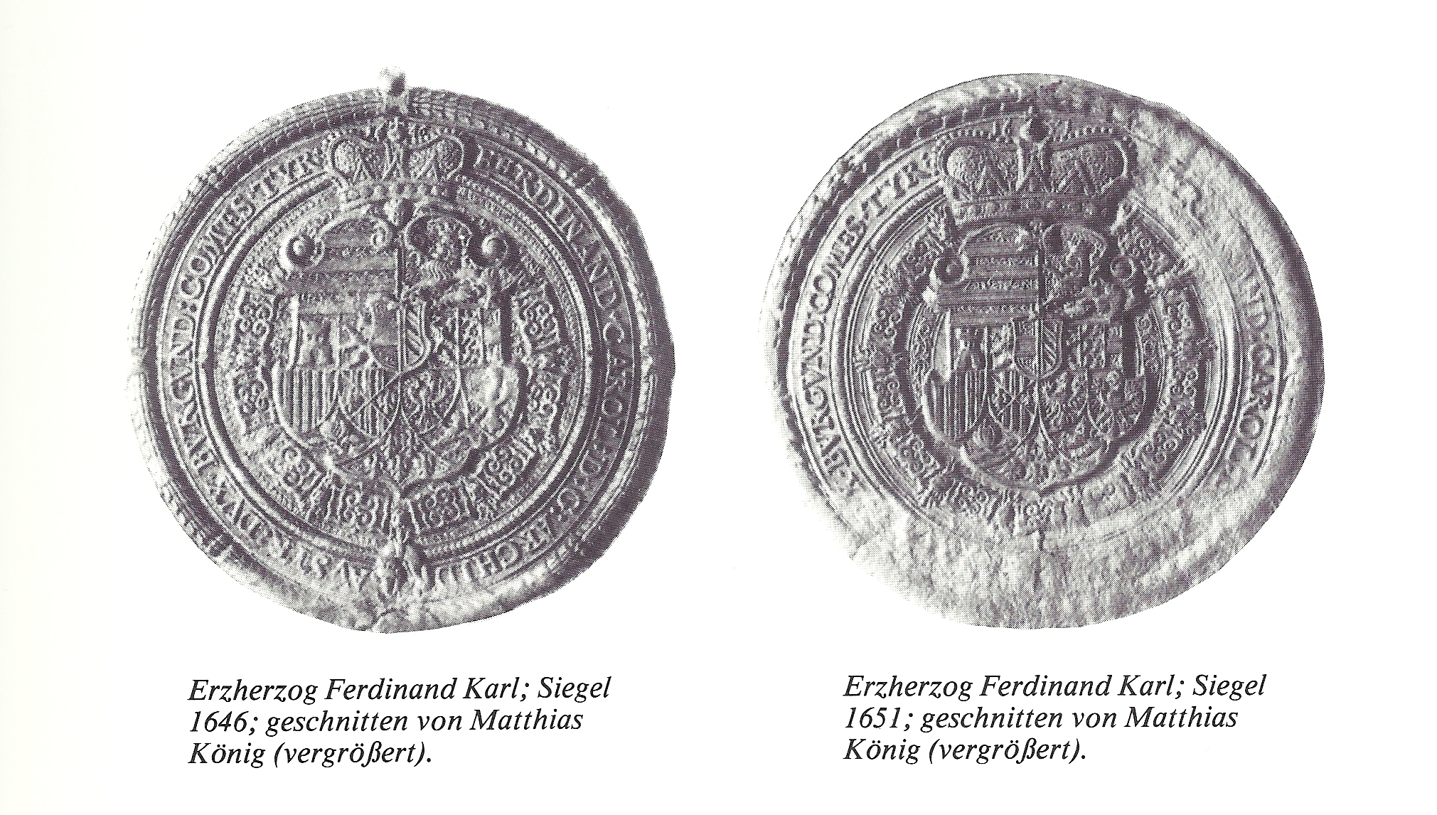
After 1647, Matthias König was not only working as supervisor of his son, but continued to supply independent work. In 1648 he cut a seal for the sister of Archduke Ferdinand Karl, Maria Leopoldina, who married Emperor Ferdinand III.
In 1646 he had already made a seal for Archduke Ferdinand Karl, which he had to renew in 1648. And he made a seal for his brother Archduke Sigismund Franz, Bishop of Passau. In 1650, he made a seal for the Nellenburg rulers, and two seals for Isabella Clara, another sister of Ferdinand Karl who married Duke Karl III of Mantua.
He cut another seal for Archduke Ferdinand Karl in 1651. In 1657 he presented a signet ring as a New Years gift. In 1660, Leo Christof, Graf of Spaur ordered a Petschaftsring from Matthias König.

In 1652 he delivered the stamp for a penny coin, which served as the front for the 1652 re-cut Taler rolls. Most likely the image on front of the so called “carousel medal” is meant to be a portrait of the Archdukes. It is consistent with the Talers of 1652. Twenty of these medals were ordered in 1652 by the Emperor Ferdinand III and were delivered to the Innsbruck court. Archduke Ferdinand Karl liked them so extraordinarily well that he even issued a decree in 1653 to cut all future Taler rolls like this medal. In fact, all Taler rolls cut after 1652 had a wide stylistic kinship with this medal. As in 1646, the embossing rollers had a stamp for Ferdinand Karl for the single Taler and a stamp of Leopold V 1632 for 4 Talers.

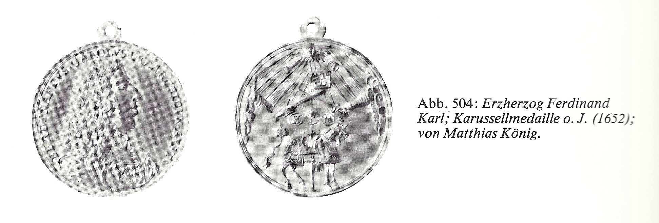

The last major work for Matthias König at the Hall mint dates from 1654. That year, he and his son cut the rolls for a Doppeltaler, whole, half and quarter Taler with the image of Archduke Ferdinand Karl. The Doppeltaler again shows the Archduke with and without a hat and carries no date. The reverse roll was not redesigned, but it was same as in 1646.
Whether Matthias König was also involved in the rollers for the minting of coins in 1662, cannot be determined from sources. He did some work for the court that had nothing to do with the Hall Mint, but some work on the rolls of 1662 cannot be excluded. In any case, the rear roller for this Taler was also used posthumously in the years 1663 and 1664, coupled with the front roller for Archduke Sigismund Franz.
The volume of coins minted under Archduke Ferdinand Karl headed towards a low point, as he had not visited the Hall mint since 1546. At first time the government of Ferdinand Karl minted about 50,000 to 60,000 fl per year. There was a significant decline from 1650 to 1658 when 30,000 to 40,000 fl were minted. Coin minting at Hall was then practically eliminated. From 1660 to 1662 only about 4,000 to 6,000 Talers were minted per year.

Page 291
Kreuzers and Vierers were minted during the reign of Archduke Ferdinand Karl at a normal weight, d.h. There were about 150,000 Kreuzers and about 300,000 Vierers minted per year. The dies were cut almost exclusively by Maximilian King, which is partly why the quality was little worse.

Pages 292 – 293
At the end of 1648 Matthias and Maximilian König were commissioned to make stamps for new Ducats. Ferdinand Karl thought of stamps for single, double, three, four and five Ducats. In 1649 he chose from two König designs the one with his portrait on the front. . During the year 1649, stamps were cut for half, single and double Ducats

Page 300
The stamp was certainly cut by Matthias König who was already collecting a yearly pension of 200 fl. It is reasonable to assume he was working for the Hall mint, at least to help his son, as he had done in previous years.

Page 302
In this short period, fewer Kreuzers and Vierers were minted. The stamps for these coins were cut by Maximilian König. Minting of the Kreuzer was on an upswing in 1665, after the recent death of Archduke Sigismund Franz

Page 303
Minting of Ducats had almost no importance during the short reign of Archduke Sigismund Franz. Annual production varied between 800 and 1600 pieces.
In 1662, under Archduke Ferdinand Karl, Matthias König had to cut an iron stamp for a gold medal weighing half a Ducat, for the Bavarian estates. It was minted in Hall at the end of 1662 or early in 1663.
These gold medals were given to the Bavarian Duchess to celebrate the birth of her son Maximilian Emanuel. This gold medal may thus be regarded as a purely Tyrolean.

Page 304
The development of Tyrolean coinage, except for the gold coinage, was on a steep upward trend under the short reign of Archduke Sigismund Franz. Through the minting of 15 Taler coins, he found a way to make the Hall mint as important as it was before 1623.
Archduke Sigismund Franz had the delivery and minting of silver in Hall for himself, and the merchants were again made ​​profitable as in the time of Emperor Leopold I. In 1659, due to debasement and technical superiority, the Hall mint was a significant center of European coin and money history for 2 years
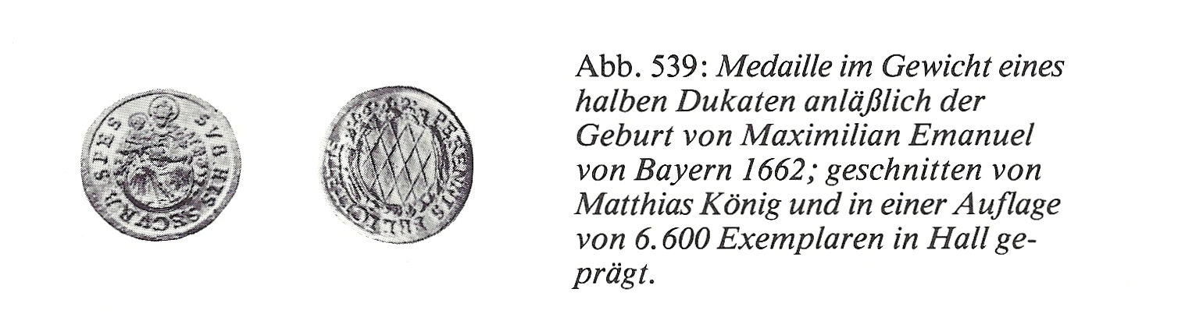
Archduke Sigismund Franz, like his father, renounced the spiritual and wanted to secure the survival of the Tyrolean line of the Habsburgs by marriage, died unexpectedly on 25 June 1665. On her way to Innsbruck for the wedding, the bride Hedwig Augusta, daughter of Count Christian August of Sulzbach, found that her groom was no longer alive.
With the death of Archduke Sigismund Franz, the strong upward trend of the Hall mint was ended as suddenly as it had begun the 1663. Their importance of Tyrol that was established under Emperor Leopold I had fallen. It was only one of the 8 imperial mints, in fourth place behind Kremnitz, Vienna and Breslau. With the death of the Tyrolean sovereign minting tens and fifteens was set and therefore Tyrol lost the basis for a profitable stamping on a large scale. Taler, Threes and Kreuzers were minted on a small scale in the coming years, compared to Tyrolean minting under Emperor Leopold I.

Page 348
A further personnel change, which had very little effect, concerned, the engravers office.
In 1630 Matthias Koenig was appointed as the engraver in both Hall and Ensisheim. This meant very little in Hall as well as in Ensisheim because the previous engravers remained in office. Koenig was therefore intended only as a helper, but did very little in Ensisheim because of the distance between the two. Stylistically there is no difference in Talers from Ensisheim

Page 350
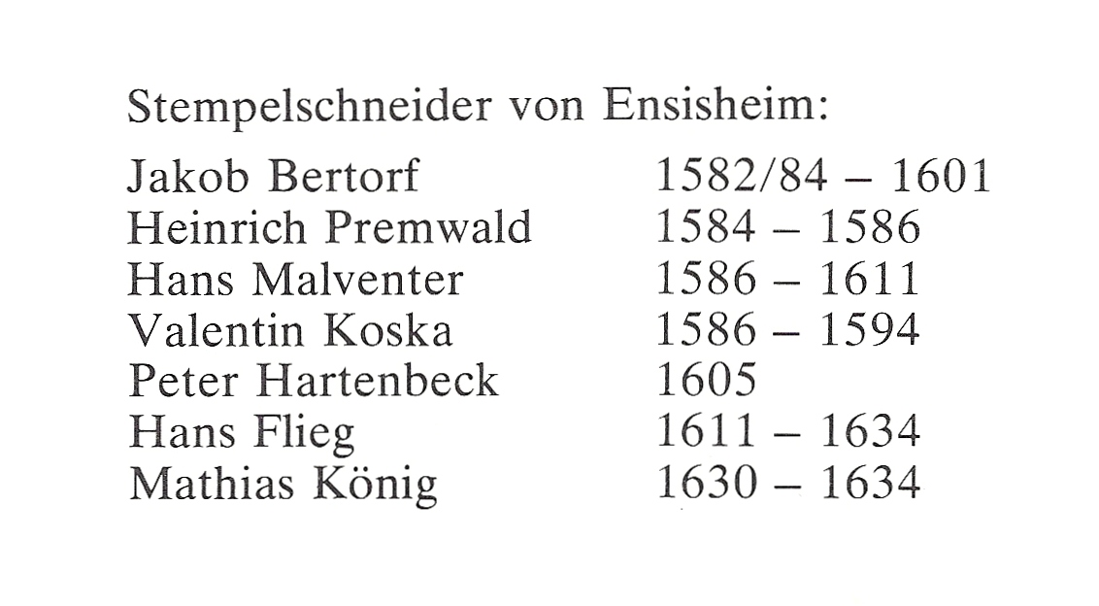

Page 354
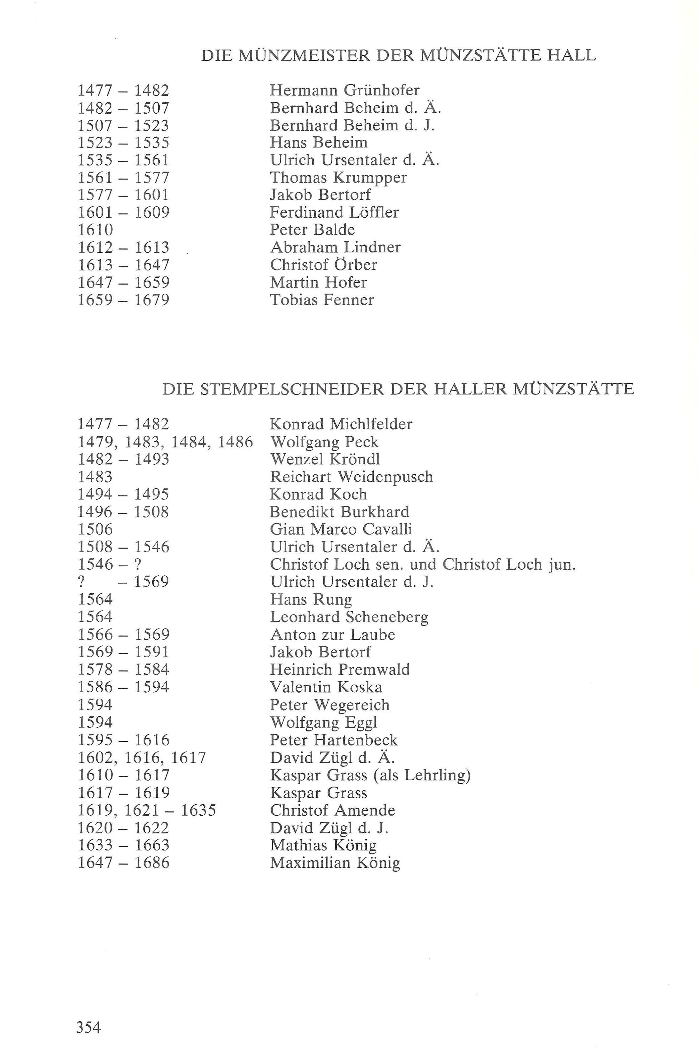
References to Wolfgang Eggl on pages 172 - 190
Page 172
In 1594 there was a further change to the situation at the mint. Valentin Koska died in the early summer of the year. The question of an appropriate successor had to be resolved quickly. Bertorf was too old to fill the position, even though he was working in the mint master’s office full time. The position was offered to Wolfgang Eggl, a very talented stone cutter and seal engraver who was living in Innsbruck. He refused the offer on the the grounds that he could earn substantially more in his previous profession. In the short period of his activity, he made no embossing rolls, but 28 dies for coinage. Other contenders were the goldsmith Cristof Hehenfelder of Hall, who was nicknamed “Möstl”, and David Zügl d.Ä. The latter worked in Hall as a goldsmith and an excellent engraver, and engraved the 1609 “Tyrolean AQUILA” following documents by Matthias Burgklechner

Pages 189 - 190
Even the number of embossing rollers previously used could not be found satisfactorily in the literature. Best known so far were the surviving Avers rolls II and III and the reverse rolls II and III, which were put together without any difficulty. Avers roll I, and reverse rolls I and IV have attracted little attention. There have been different opinions about the engravers of the rolls. It may have been Valentine Koska who engraved roll pair II and III, or Wolfgang Eggl for roller pair III and Peter Hartenbeck for pair II. The question is unresolved. None of these opinions could ultimately be proven.
Some certainty in these matters can be found in the written records of the time. It could be one of the stamp cutters Bertorf Jacob (1569-1591), Heinrich Premwald (1578-1584), Valentin Koska (1586-1594), Peter Wegereich (1594), Wolfgang Eggl (1594) and Peter Hartenbeck from 1595) with some certainty about the retired candidates. Jacob Bertorf had the artistic talents to do so. On the other hand, since 1578 the engraving service again and again had to be provided by agents, such as Premwald whose artistic talent has certainly not up to the standard need by such a high-quality stamp for the Double Taler, in time nor style. Peter Wegereich and Wolfgang Eggl are also out of the question because it is known exactly what work they delivered to the Hall mint, and the Double Taler roll was not included.

